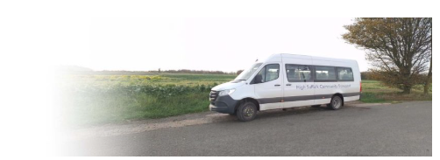

High Suffolk Community Transport

Check out the innovative bus route map, serving local villages Worlingworth, Bedfield, Bedingfield, Tannington, Kenton and Mark Soham.
The service is run completely by volunteers, even the drivers. We rely on both passenger donations and local trusts and parishes for our funds. We do not have core funds from the council.

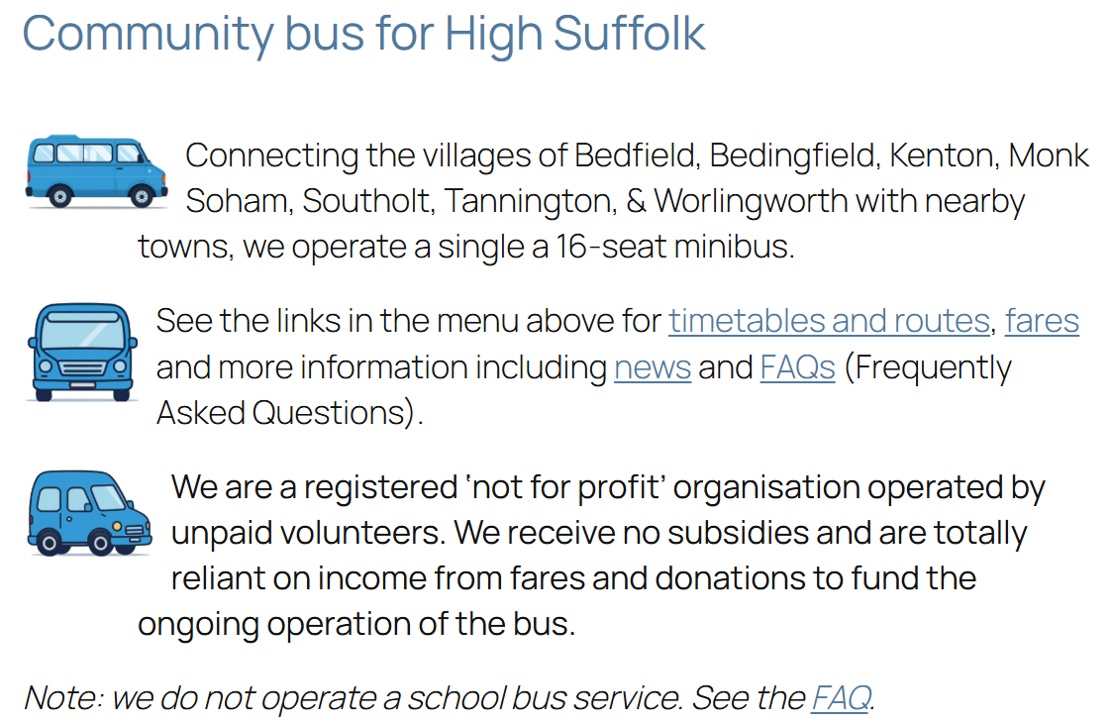

Check out our website for further information – www.combus.org.uk
It incorporates a number of new features including maps of bus routes and bus stops, a Frequently Asked Questions section and more information about the service.
Or email our General Support at support@combus.org.uk

